**INSTALLATION OF VISUAL STUDIO CODE COMMUNITY 2019**

1. Check the python version,it should be a 3.8.1 and 64 bit version.
2. Make sure that you have only one python version of 64 bit.
3. 
4. If you have multiple versions of python then go to Add or Remove programs and then uninstall the older versions of python and make sure there is only a 64bit version.
5. Download Visual Studio Community 2019.
6. 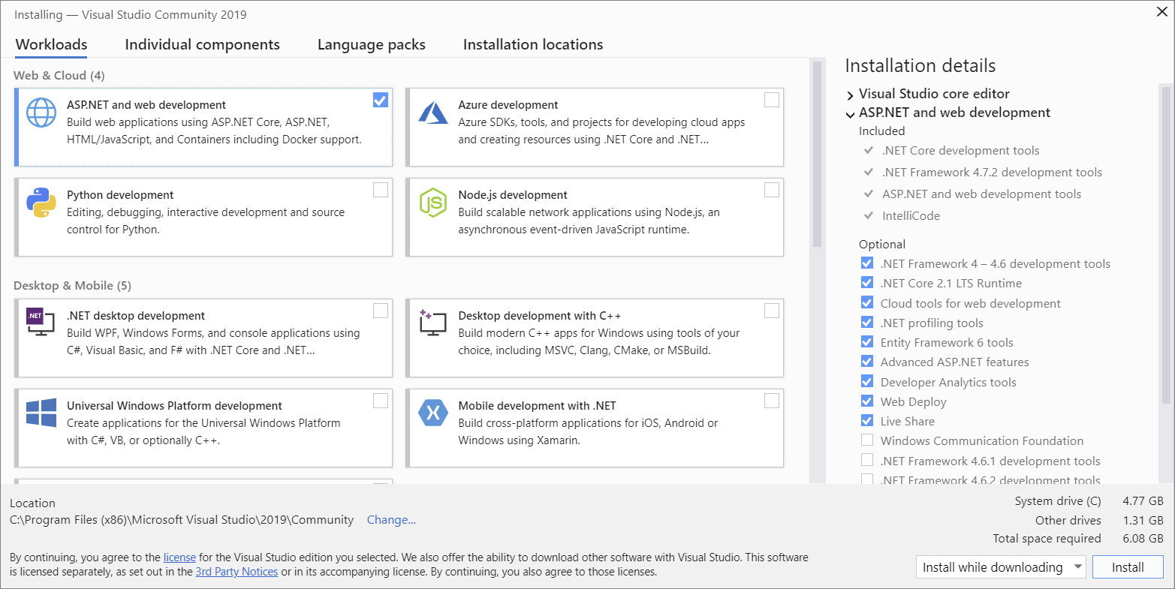
7. From the above picture now select the Python Development and Desktop Development with C++
8. Then Click install While Downloading
9. After the installation it will ask to reboot the system then make the reboot and launch the Visual Studio Community 2019.
10. If you have uninstalled the multiple versions of python and installed an upgrade for it then check the upgrade in cmd

*python -m pip install --upgrade pip

1. If you reinstalled the python you have to install the packages by the commands in command prompt
2. Pip install opencv-python
3. Pip install matplot
4. Pip install scipy
5. Pip install scikit-learn
6. Pip install scikit-image
7. Then Open Command Prompt and make the following two commands to install face_recognition
8. Pip install cmake
9. Pip install face_recognition